Jenkins Installation and Configuration SOP


Table of Contents

1. Jenkins Installation and Configuration 3
1.1 Description 3
1.2 Architecture Diagram 3
1.3 Lab Steps 4
1.4 Troubleshooting 7
1.5 Supporting References 7

Jenkins Installation and Configuration

Description
Jenkins® is an open source automation server. With Jenkins, organizations can accelerate the software development process by automating it. Jenkins manages and controls software delivery processes throughout the entire lifecycle, including build, document, test, package, stage, deployment, static code analysis and much more.

We can set up Jenkins to watch for any code changes in places like GitHub, Bitbucket or GitLab and automatically do a build with tools like Maven and Gradle. We can utilize container technology such as Docker and Kubernetes, initiate tests and then take actions like rolling back or rolling forward in production.

Architecture Diagram
The diagram below displays a visual representation of the underlying application architecture:
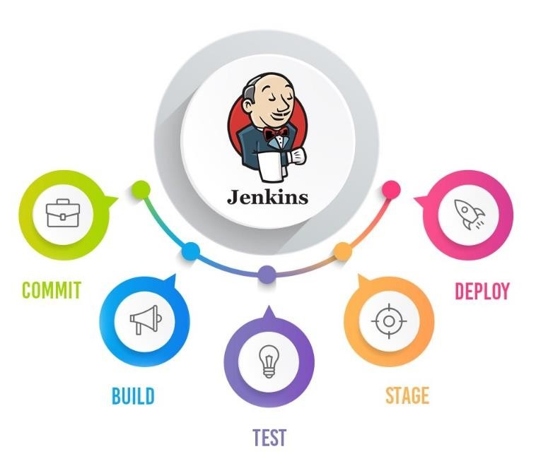

Lab Steps
Jenkins is a well-known open-source continuous integration and continuous development automation tool. Jenkins Pipeline is a combination of plugins that support the integration and implementation of continuous delivery pipelines using Jenkins.
Follow the steps outlined below to achieve the objectives of this lab exercise:

Prerequisites:
- Sign in to the AWS Management Console.
- An Amazon EC2 key pair, if you do not have one.

1. Install the Jenkins and docker in AWS machine and execute the build steps
a. Execute the following steps to install the Jenkins in Centos 7 machine:
- Once you open your AWS machine or any other cloud instance get into root mode.

- Enter the following address from your web browser to test Jenkins:
http://< your_public_ip_address >:8080
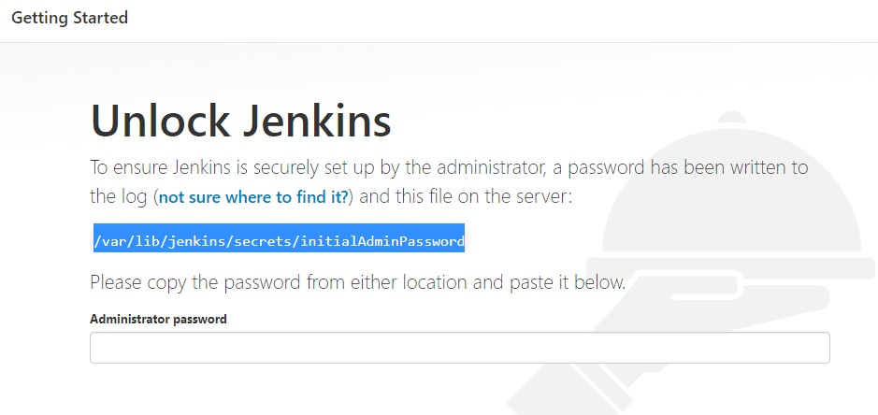
Once you enter
the browser
,

the below screen
displays
:

- Type the following command in your Jenkins server and get the password and paste it in the Administrator password section in the above screen:
cat /var/lib/jenkins/secrets/initialAdminPassword

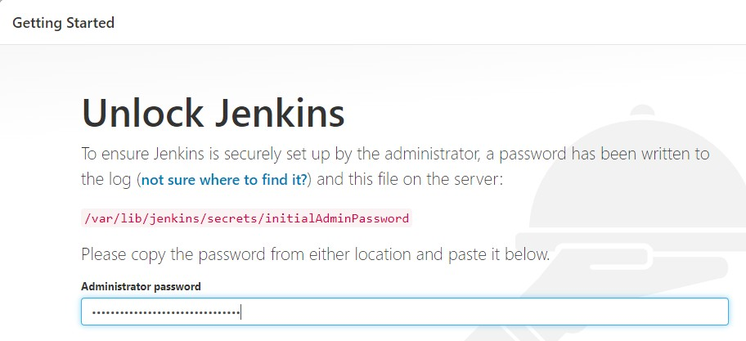
- Select the Install suggested plugins option:
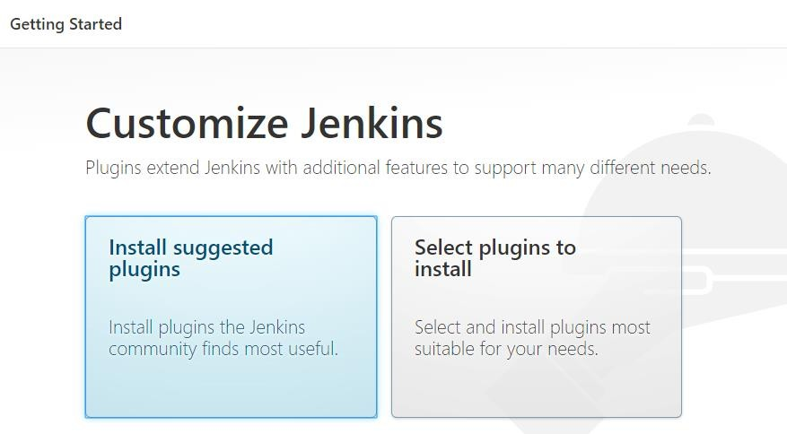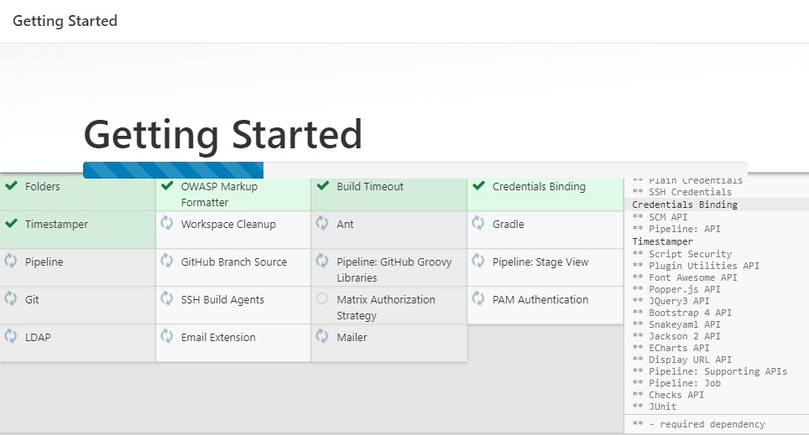

- Click Save and Continue once you provided the required info in the screen:
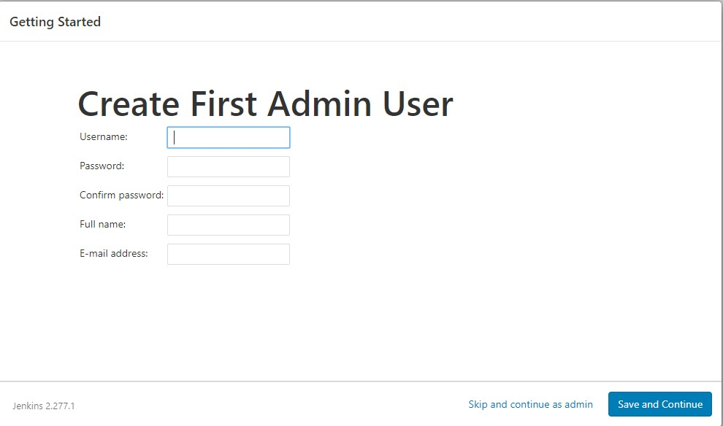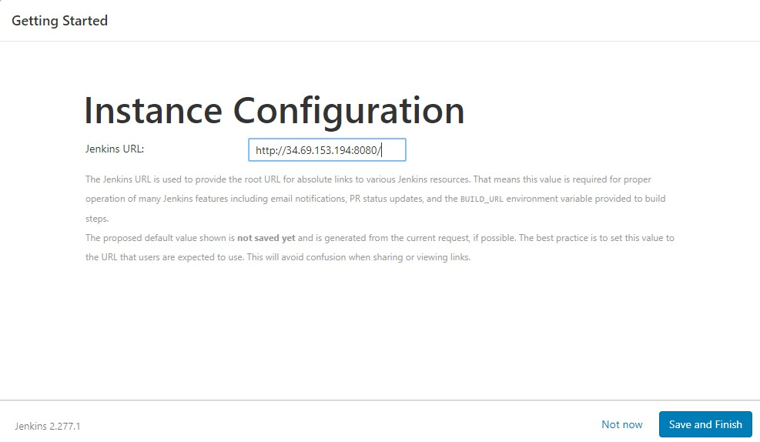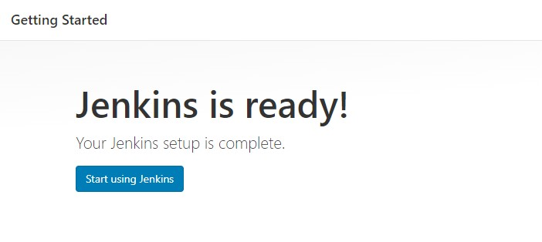
vi.

Click
Save and Finish

button:

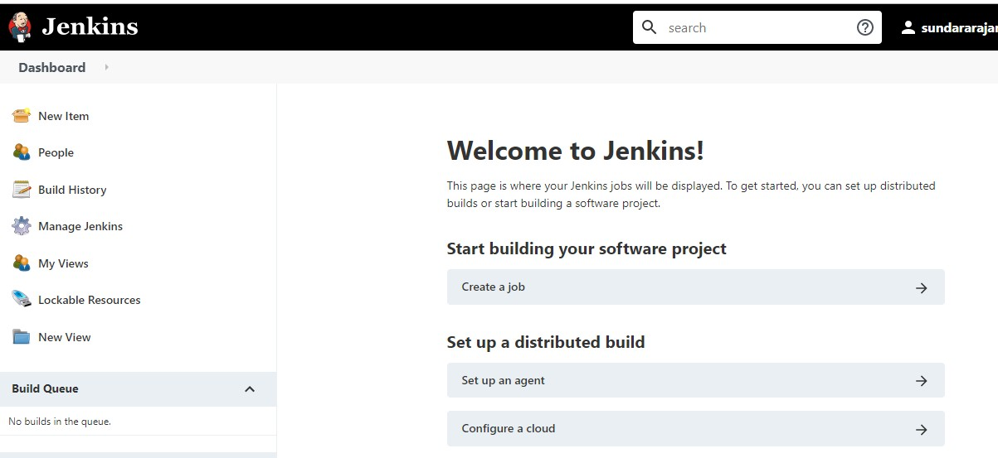

Troubleshooting
S. No | Problem | Solution
1 | Jenkins not able to launch it in the port  8080 and receiving page not found error. | Open the firewall for specified port in cloud environment.

Supporting References
Refer the below link for additional information:

1. https://medium.com/appgambit/build-pipeline-with-jenkins-c13bf788a3f0

